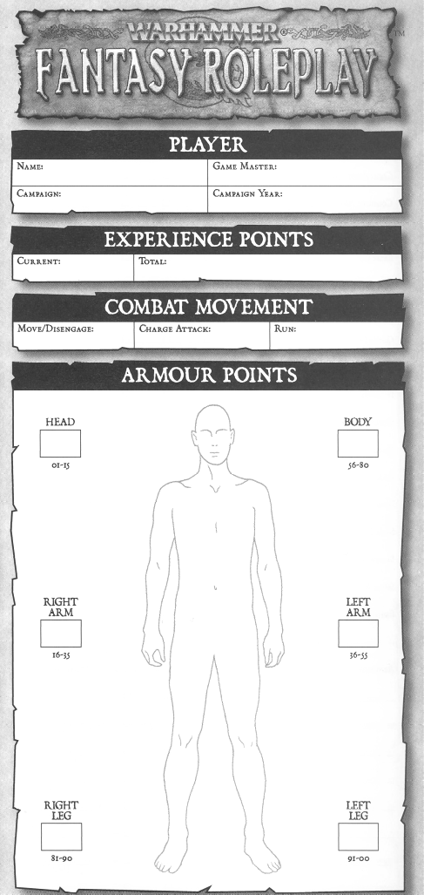
CHARACTER
Name:
Race:
Current Career:
Previous Career:

PERSONAL DETAILS
Age: | Gender:
Eye Colour: | Weight:
Hair Colour: | Height:
Star Sign: | Number of Siblings:
Birthplace:
Distinguishing Marks:

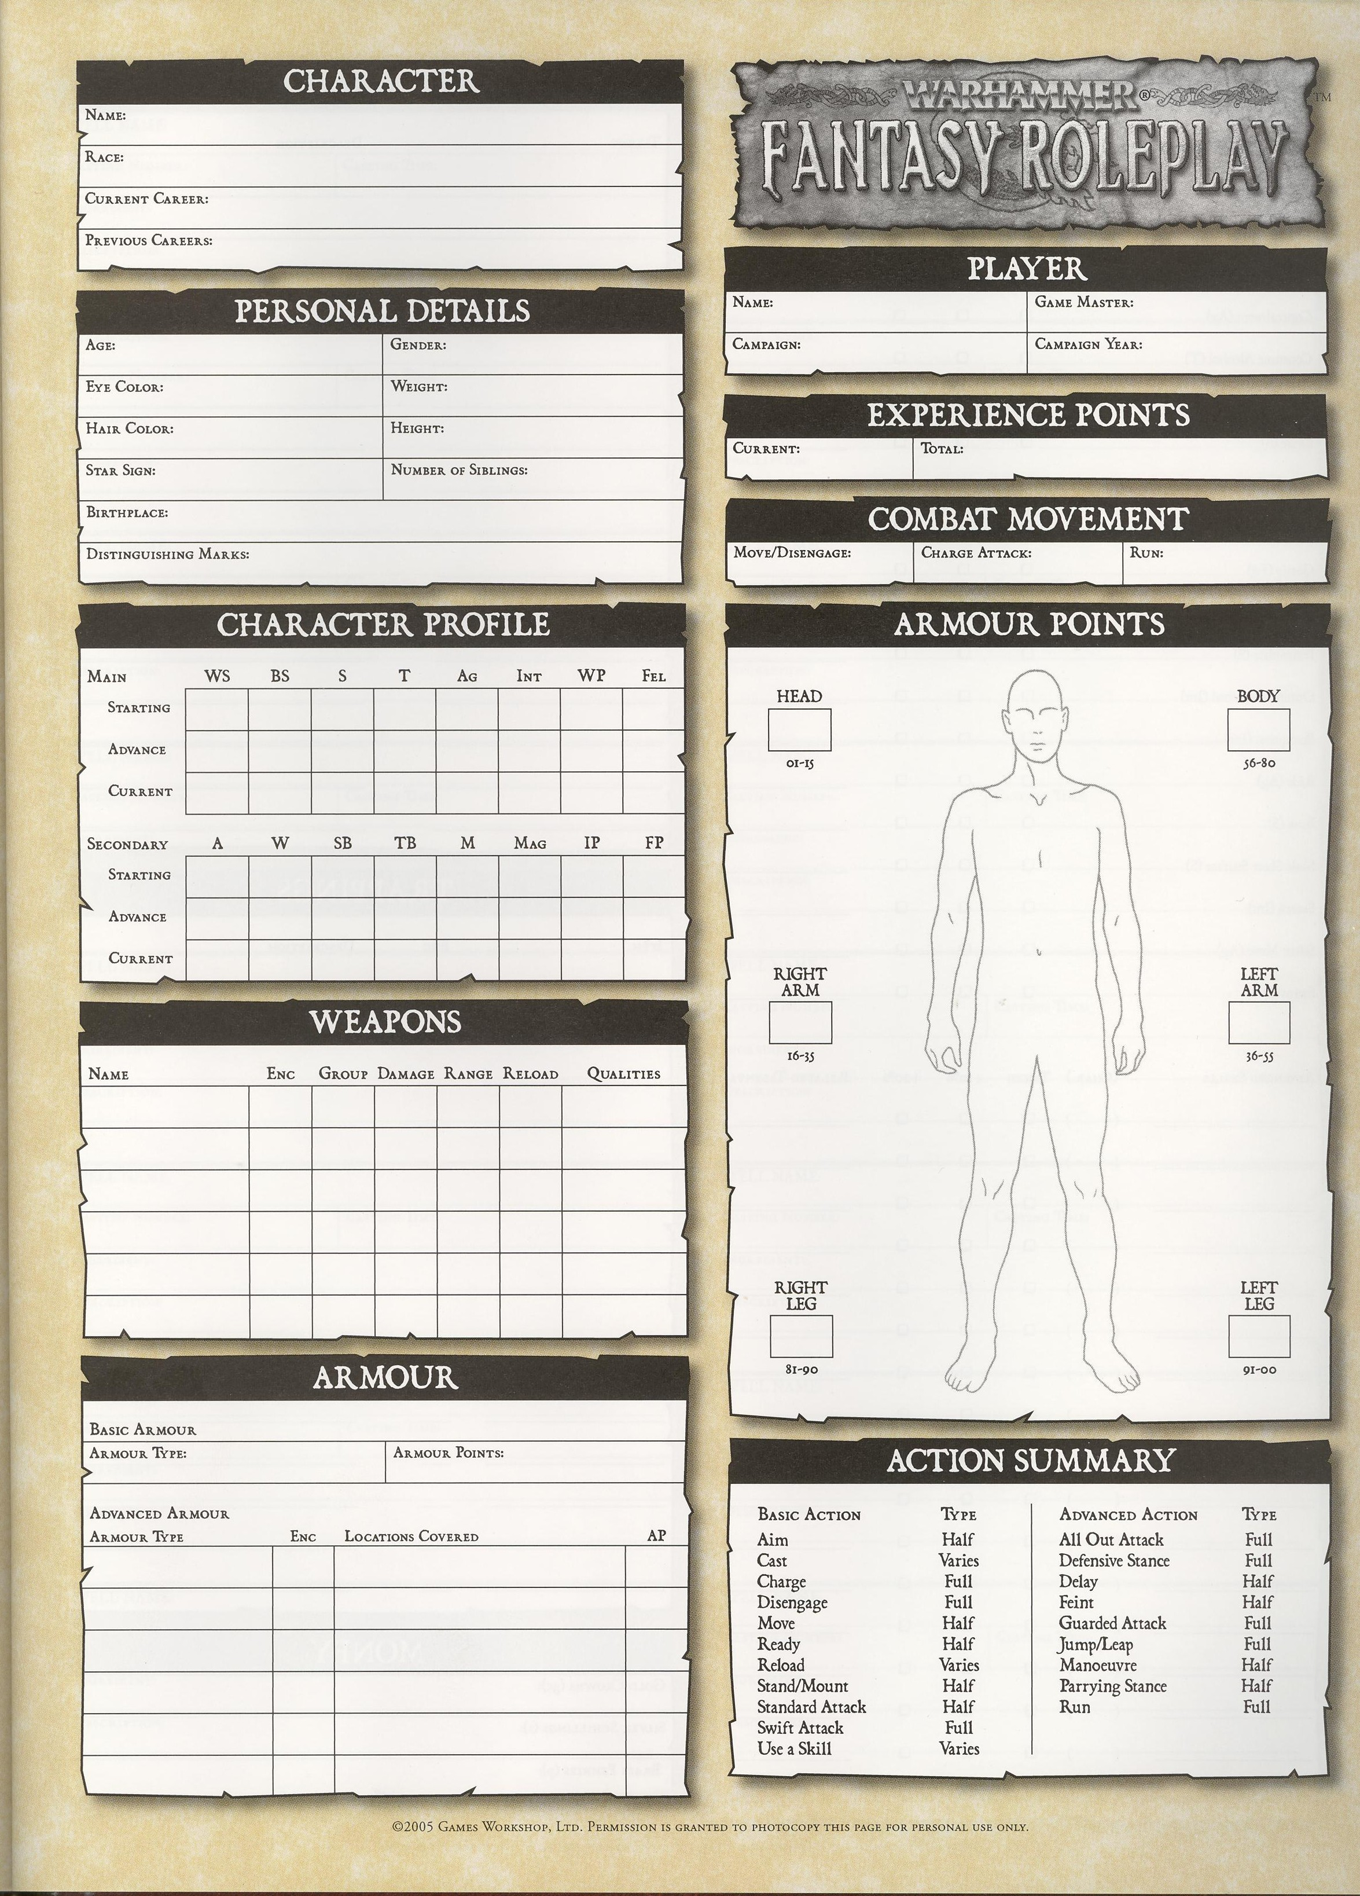
CHARACTER PROFILE
HEAD

01 - 15
Main | WS | BS | S | T | Ag | Int | WP | Fel
Starting
Advance
Current
RIGHT ARM

16 - 35
Secondary | A | W | SB | TB | M | Mag | IP | FP  LEFT ARM  36 - 55
Starting
Advance
Current

WEAPONS
RIGHT LEG

81 - 90
LEFT LEG

90 - 00
Weapon | Group | Enc | Damage | Range | Reload
Qualities:
Weapon | Group | Enc | Damage | Range | Reload
Qualities:
Weapon | Group | Enc | Damage | Range | Reload
Qualities:
Weapon | Group | Enc | Damage | Range | Reload
Qualities:
Weapon | Group | Enc | Damage | Range | Reload
Qualities:
PLAYER
Name: | Game Master:
Campaign: | Campaign Year:

EXPERIENCE POINTS
Current: Total:

COMBAT MOVEMENT
Move/Disengage: | Charge Attack: | Run:
ARMOUR POINTS
ARMOUR
BODY

56 - 80
Armour Type | Locations Covered | Enc. | AP
ACTION SUMMARY
Aim Half Cast Varies Charge Full
Disengage Full Move Half Ready Half
Stand/Mount Half Reload Varies Use Skill Varies
Standard Attack Half Swift Attack Full Delay Half
All Out Attack Full Jump/Leap Full Run Full
Defensive Stance Full Manoeuvre Half Feint Half
Parrying Stance Half Guarded Attack Full

SKILLS
Advanced Skills  (Characteristic) | Avail/Taken | + 10% | + 20% | Related Talents
Academic Knowledge - Arts (Int) | / |  |  | N/A
Academic Knowledge - Astronomy (Int) | / |  |  | N/A
Academic Knowledge - Daemonology (Int) | / |  |  | N/A
Academic Knowledge - Engineering (Int) | / |  |  | N/A
Academic Knowledge – Genealogy/Heraldry (Int) | / |  |  | N/A
Academic Knowledge - History (Int) | / |  |  | N/A
Academic Knowledge - Law (Int) | / |  |  | N/A
Academic Knowledge - Magic (Int) | / |  |  | N/A
Academic Knowledge - Necromancy (Int) | / |  |  | N/A
Academic Knowledge - Philosophy (Int) | / |  |  | N/A
Academic Knowledge - Runes (Int) | / |  |  | N/A
Academic Knowledge - Science (Int) | / |  |  | N/A
Academic Knowledge – Strategy/Tactics (Int) | / |  |  | N/A
Academic Knowledge - Theology (Int) | / |  |  | N/A
Academic Knowledge - ___________ (Int) | / |  |  | N/A
Animal Training (Fel) | / |  |  | N/A
Blather (Fel) | / |  |  | N/A
Channelling (WP) | / |  |  | Aethyric Attunement
Charm Animal (Fel) | / |  |  | N/A
Common Knowledge (Int) - Border Princes, Bretonnia, Dwarfs, Elves, The Empire, Estallia, Halflings, Kislev, Norsca, Ogres, Tilea, The Wasteland, ________, __________ | / |  |  | Seasoned Traveller
Dodge Blow (Ag) | / |  |  | N/A
Follow Trail (Int) | / |  |  | N/A
Heal (Int) | / |  |  | Surgery
Hypnotism (WP) | / |  |  | N/A
Lip Reading (Int) | / |  |  | Excellent Vision
Magical Sense (WP) | / |  |  | Aethyric Attunement
Navigation (Int) | / |  |  | Orientation, Super Numerate
Performer - __________ (Int) | / |  |  | Contortionist/ Mimic
Performer - __________ (Int) | / |  |  | Contortionist/ Mimic
Performer - __________ (Int) | / |  |  | Contortionist/ Mimic

Performer - __________ (Int) | / |  |  | Contortionist/ Mimic
Pick Lock (Ag) | / |  |  | Trapfinder
Prepare Poison (Int) | / |  |  | N/A
Read / Write (Int) | / |  |  | Linguistics
Sail (Ag) | / |  |  | N/A
Secret Language (Int) –  Battle Tongue, Guild Tongue, Thieves’ Tongue, Ranger Tongue, _____________ | / |  |  | N/A
Secret Signs (Int) -  Scout, Templar, Thief, Ranger, _____________ | / |  |  | N/A
Set Trap (Ag) | / |  |  | N/A
Shadowing (Ag) | / |  |  | N/A
Sleight of Hand (Ag) | / |  |  | N/A
Speak Language – Arcane ________ (Int) | / |  |  | N/A
Speak Language – Arcane ________ (Int) | / |  |  | N/A
Speak Language (Int) – Breton, Eltharin, Estalian, Halfling, Khazalid, Kislevian, Norse, Reikspeil, Tilean, Classical, Dark Tongue, Goblin Tongue, Grumbarth, __________ | / |  |  | Linguistics, Mimic, Seasoned Traveller
Torture (Fel) | / |  |  | Menacing
Trade - _____________ (____) | /
Trade - _____________ (____) | /
Trade - _____________ (____) | /
Trade - _____________ (____) | /
Trade - _____________ (____) | /
Ventriloquism (Fel) | / |  |  | N/A
 | /
 | /
 | /
TALENTS
Avail/  Taken | Talent | Description
/ | Acute Hearing | +20% Perception (Listening)
/ | Aethyric Attunement | +10% Channelling /Magical Sense
/ | Alley Cat | +10% Concealment/Silent Move in Urban Environment
/ | Ambidextrous | No -20% for 2nd Hand Use
/ | Arcane Lore – Beasts, Death, Fire, The Heavens, Life, Light, Metal & Shadow | Allows Spells to be Cast from studied Lore
/ | Armoured Casting | Casting Roll penalty reduced by 3
/ | Artistic | +20% Trade (Artist) & +10% Evaluate Object d’art
/ | Contortionist | +10% relevant Performer and +20% relevant Agility tests
/ | Coolheaded | Permanent 5% bonus to WP
/ | Dark Lore – Chaos, Necromancy, _________ | Allows Spells to be Cast from studied Lore
/ | Dark Magic | Allows Dhar to be used.
/ | Dealmaker | +10% Evaluate & Haggle
/ | Disarm | Disarm instead of Damage - Melee
/ | Divine Lore – Grungni, Manann, Morr, Myrmidia, Ranald, Sigmar, Shallya, Taal/Rhya, Ulric, Verena | Allows Spells to be Cast from studied Lore
/ | Dwarfcraft | +10% Dwarf Trade Skills
/ | Etiquette | +10% Charm & Gossip - Nobility
/ | Excellent Vision | +10% Perception (Sight) & Lip Reading
/ | Fast Hands | +20% WS casting touch spells
/ | Fearless | Immune to Fear, Intimidate & Unsettling.
/ | Flee! | +1 to Movement for 1d10 rounds to escape combat or threat
/ | Fleet Footed | Permanent +1 bonus to M
/ | Flier | You can Fly!
/ | Frenzy | 1 round to psyche then +10% to S & WP, -10% WS & Int
/ | Frightening | Cause Fear
/ | Grudge-born Fury | +5% WS vs Orcs, & Goblins
/ | Hardy | Permanent +1 bonus to W
/ | Hedge Magic | Cast Petty Magic (Hedge)
/ | Hoverer | You can Fly low to the ground
/ | Keen Senses | +20% to Perception Tests
/ | Lesser Magic – Aethyric Armour, Blessed Weapon, Dispel, Magic Alarm, Magic Lock, Move, Silence, Skywalk | Allows Spells to be Cast from studied list. Each is a separate talent.
/ | Lightning Parry | Swift Attack, swap 1 for free Parry
/ | Lightning Reflexes | Permanent 5% bonus to Ag
/ | Linguistics | +10% Read/Write & Languages
/ | Luck | 1 extra Fortune Point / Day
/ | Marksman | Permanent 5% bonus to BS
/ | Master Gunner | Reduce Blackpowder reload by ½ Action
/ | Master Orator | Charm x 100 people, requires Public Speaking first.
/ | Meditation | Ritual Magic Bonus Cast Roll = Mag
/ | Menacing | +10% Intimidate & Torture
/ | Mighty Missile | +1 Damage with Magic Missile
/ | Mighty Shot | +1 Damage with Missile Weapon
/ | Mimic | +10% Performer, Disguise (Verbal) & Language (passing as a native)

/ | Natural Weapons | Teeth, Claws etc. Counts as Hand Weapons, can’t be disarmed
/ | Night Vision | See in Natural Darkness up to 30 yards – doesn’t work in total dark.
/ | Orientation | +10% bonus to Navigation Tests
/ | Petty Magic – Arcane, Divine, Hedge | Can attempt to cast Petty Magic from studied list.
/ | Public Speaking | Charm x 10 people.
/ | Quick Draw | Once / round ready action for free
/ | Rapid Reload | Reduce Weapon reload by ½ Action
/ | Resistance to Chaos | +10% to WP vs Magic & Chaos
/ | Resistance to Disease | +10% to T vs Disease
/ | Resistance to Magic | +10% to WP vs Magic
/ | Resistance to Poison | +10% to T vs Poison
/ | Rover | +10% Concealment & Silent Move in Rural locations
/ | Savvy | Permanent 5% bonus to Int
/ | Schemer | +10% on intrigue-related Charm tests, & WP to resist others’ Charm.
/ | Seasoned Traveller | +10% Common Knowledge & Speak Language
/ | Sharpshooter | +20% BS for aimed shot
/ | Sixth Sense | You have a bad feeling… (WP)
/ | Specialist Weapon Group – Cavalry, Crossbow, Engineer, Entangling, Fencing, Flail, Gunpowder, Longbow, Parrying, Sling, Throwing, Two-Handed, _____________ | Allows specialist weapons to be used at full functionality.
/ | Stout-hearted | +10% bonus on Fear & Terror tests and WP vs Intimidate
/ | Street Fighting | +10% WS unarmed +1 Damage.
/ | Streetwise | +10% bonus Charm & Gossip related to criminal underworld
/ | Strike Mighty Blow | +1 damage w/ melee weapons
/ | Strike to Injure | Critical Value increased by 1
/ | Strike to Stun | S vs T +10%/Head AP, stun not damage – out for 1d10 rounds
/ | Strong-minded | No check until 8 IP, No insanity until 14
/ | Sturdy | No M penalties Heavy/Plate Armour
/ | Suave | Permanent 5% bonus to Fel
/ | Sure Shot | Ignore One AP on Target
/ | Surgery | +10% Heal, 2W for Heavy Wounds
/ | Super Numerate | +10% Gamble & Navigation, +20% Perception (Estimation)
/ | Swashbuckler | Jump/Leap Half Action, Jump increased by 1 yard.
/ | Terrifying | Cause Terror
/ | Trapfinder | +10% Pick Locks & Perception (Find / Disarm Traps)
/ | Trick Riding | Ride Tests only in extremes, then +10%
/ | Tunnel Rat | +10% Concealment & Silent Move Underground
/ | Undead | You’re Not Dead! Immune to Fear, Terror, Stunning, Poison, Disease and All Spells / skills / effects that involve emotion and the mind.
/ | Unsettling | Opponents WP test or suffer -10% WS & BS
/ | Very Resilient | Permanent 5% bonus to T
/ | Very Strong | Permanent 5% bonus to S
/ | Warrior Born | Permanent 5% bonus to WS
/ | Wrestling | Unarmed attacks +10% to grapple. +10% Grappling Strength
/
BASIC SKILLS
Basic Skills  (Characteristic) | Taken | + 10% | + 20% | Related Talents
Animal Care (Int) |  |  |  | N/A
Charm (Fel) |  |  |  | Etiquette, Master Orator, Public Speaking, Schemer, Streetwise
Command (Fel) |  |  |  | N/A
Concealment (Ag) |  |  |  | Alley Cat, Rover, Tunnel Rat
Consume Alcohol (T) |  |  |  | N/A
Disguise (Fel) |  |  |  | Mimic
Drive (S) |  |  |  | N/A
Evaluate (Int) |  |  |  | Artistic, Dealmaker
Gamble (Fel) |  |  |  | Super Numerate
Gossip (Fel) |  |  |  | Etiquette, Streetwise
Haggle (Fel) |  |  |  | Dealmaker
Intimidate (S) |  |  |  | Menacing
Outdoor Survival (Int) |  |  |  | N/A
Perception (Int) |  |  |  | Acute Hearing, Excellent Vision, Super Numerate, Trapfinder
Ride (Ag) |  |  |  | Trick Riding
Row (S) |  |  |  | N/A
Scale Sheer Surface (S) |  |  |  | N/A
Search (Int) |  |  |  | N/A
Silent Move (Ag) |  |  |  | Alley Cat, Rover, Tunnel Rat
Swim (S) |  |  |  | N/A

TRAPPINGS

NOTES

Item |  | Enc. | Description

MONEY
Gold Crowns (GC ):
Silver Schillings (S ):
Brass Pennies (P ):
Treasure:

